Confirmation Bias in Media

Abstract
This study examines how confirmation bias shapes contemporary media consumption and fuels ideological polarization. Drawing on social cognition theories of selective exposure and motivated reasoning, it explores how individuals construct personalized information environments that reinforce existing beliefs while avoiding contradictory perspectives. The research focuses on three key dimensions: (1) selective media consumption, where individuals prefer ideologically aligned news sources, influencers, and social networks, creating self-imposed filter bubbles; (2) psychological mechanisms of belief persistence, including motivated reasoning, cognitive dissonance reduction, and the backfire effect when faced with opposing information; and (3) technological amplification, through algorithmic curation, social media echo chambers, and AI-driven recommendations that intensify these cognitive tendencies.
Empirical evidence shows that selective exposure strengthens polarization and reduces critical evaluation of supporting information. To explain this process, the study proposes a Media-Mediated Confirmation Cycle model, integrating individual cognitive biases with media system dynamics to reveal how belief reinforcement becomes self-sustaining. Finally, it investigates moderating factors such as need for cognition, intellectual humility, and media literacy that may weaken confirmation bias effects. By identifying points of intervention within this cycle, the research aims to promote intellectual diversity and critical engagement with information offering implications for media literacy education, journalism, and efforts to address societal polarization.

1. Introduction
Modern society is facing increasing emotional and ideological divisions, which hinder constructive political discussion and weaken social unity. While the causes are complex, a significant contributor is the interaction between fundamental human psychology and the structure of the modern media environment. Social media, in particular, is one of the key drivers in polarising views on politics, climate change, public health crises , etc.
This polarization is driven by confirmation bias — the human tendency to look for or interpret information in ways that support one’s existing beliefs or expectations. Psychologist Raymond Nickerson described it as “perhaps the best-known and most widely accepted form of reasoning error,” highlighting how deeply it shapes the way people think.
In the current media landscape, this cognitive tendency is intensified by two concurrent developments: media fragmentation and technological curation. Unlike the broadcast era, today’s fragmented environment enables individuals to selectively engage with content that aligns with their existing beliefs, fostering the emergence of “filter bubbles” and “echo chambers.” Further compounding this, algorithm-driven curation systems reinforce users’ pre-existing preferences, structurally limiting exposure to cross-ideological perspectives. Ironically, in an age characterized by unprecedented information accessibility, people are becoming increasingly polarized within their own digital echo chambers.
This paper argues that these elements have created a self-sustaining Media-Mediated Confirmation Cycle. This model integrates individual cognitive biases (selective exposure, motivated reasoning) with media system dynamics (algorithmic filtering, echo chambers) to explain how belief reinforcement becomes automated and persistent, ultimately strengthening polarization. We will first explore the psychological foundations of this bias, then analyze its manifestation in media consumption and amplification by technology, and finally propose a model of this cycle and explore potential moderating factors, such as intellectual humility, that may offer a path toward mitigating its effects.

1.1 Methodology & Rationale
This study employs a thematic literature review approach to analyze how confirmation bias operates within contemporary media systems. Five peer-reviewed papers were selected for their theoretical and empirical relevance, representing psychology, communication, and information systems perspectives.
The selected works include:
- Nickerson(1998) for confirmation bias and cognitive dissonance,
- Kunda (1990) for motivated reasoning,
- Johnson et al. (2020) for selective exposure and sharing,
- Modgil et al. (2024) for social media-induced polarization,
- Barrera-Rodriguez et al. (2025) for media fragmentation and political polarization, and
- Knöchelmann & Cohrs (2024) for intellectual humility as a moderating factor.
Data were collected from reputable academic databases and analyzed thematically across three dimensions: selective media consumption, psychological mechanisms of belief persistence, and technological amplification. The insights were synthesized into a conceptual model—the Media-Mediated Confirmation Cycle—that integrates individual cognitive biases with media system dynamics to explain the self-reinforcing nature of ideological polarization.

2. TOPICS
I Cognitive Foundations of Confirmation Bias

2.1 Confirmation Bias

Confirmation bias is a cognitive tendency where individuals preferentially seek out, interpret, recall, and favor information that aligns with their pre-existing beliefs. This process involves giving greater weight to evidence that supports one's existing views while simultaneously dismissing, undervaluing, or avoiding contradictory evidence. This bias is often rooted in cognitive dissonance theory, which proposes that individuals seek to avoid the psychological discomfort arising from information that challenges their beliefs. As Nickerson (1998) comprehensively outlined, confirmation bias infuses many aspects of human reasoning, from everyday judgments to scientific inquiry, often reinforcing existing attitudes and worldviews. In media consumption, this tendency manifests as a preference for like-minded content and is a well-documented phenomenon in both the selection (exposure) and subsequent sharing of news.

2.2 Motivated Reasoning
Ziva Kunda's (1990) foundational work argues for a "case for motivated reasoning," proposing that while people want to see themselves as rational, their cognitive processes are biased toward conclusions they want to reach. Motivation affects reasoning by influencing the choice of cognitive strategies used for accessing, constructing, and evaluating beliefs.
Crucially, people are not at liberty to conclude whatever they wish. The bias is constrained by their ability to "construct seemingly reasonable justifications for these conclusions". They search memory for beliefs and rules that support their desired conclusion, maintaining an "illusion of objectivity". This mechanism explains why confirmation bias feels objective to the person engaging in it.

2.3 Cognitive Dissonance

This motivation of wanting the conclusion they want to reach, is often driven by a desire to avoid cognitive dissonance, the psychological discomfort experienced when encountering information that contradicts pre-existing beliefs or values. Kunda (1990) explains this through the theory of motivated reasoning, in which individuals unconsciously adapt their evaluation of information to defend pre-existing attitudes and maintain psychological consistency. Nickerson (1998) further characterizes this as the core mechanism of confirmation bias, describing how people selectively seek, interpret, and recall information that supports their beliefs while minimizing the psychological strain of conflicting evidence. To reduce this discomfort, individuals selectively consume information that confirms their biases. In a media context, this means individuals are motivated to consume information that reinforces their beliefs—not simply because they see it as “right,” but because it is psychologically comfortable, a pattern also reflected in Johnson et al. (2020), who link such selective exposure to digitally mediated information environments.

II Selective Media Consumption and Expression
Confirmation bias manifests in the media environment primarily as selective exposure and selective sharing.
- Selective Exposure: Individuals have a tendency to choose and spend more time with information that aligns with their existing views. Users will search for, believe, and recall information that confirms their pre-existing beliefs while ignoring or discounting information that challenges them. This behavior, rooted in confirmation bias, aligns with Kunda’s (1990) concept of motivated reasoning, where people process information in ways that protect their prior attitudes. Over time, this leads individuals to construct self-imposed "filter bubbles," a phenomenon reinforced by social media algorithms that magnify like-minded content, as shown by Modgil et al. (2021) in their study on digital polarization.
- Selective Sharing: While selective exposure is a passive act of consumption, selective sharing is an active, expressive behavior. Johnson et al. (2020) found that confirmation bias manifests more strongly in selective sharing than in exposure, as users tend to share content aligned with their attitude as a visible statement of partisan loyalty. Sharing ideologically aligned material thus becomes a clear reflection of one’s political identity and a signal of in-group belonging. Because it represents a greater behavioral commitment, selective sharing is often a more robust predictor of political outcomes than selective exposure alone.
This selective consumption and sharing is the behavioral engine of polarization, with evidence showing that pro-attitudinal sharing predicts both attitude polarization and political participation (Johnson et al., 2020).

III Belief Persistence and Polarization
2.4 Affective and Political Polarization
Political polarization refers to the ideological division within a society, a phenomenon significantly amplified by modern media dynamics. A specific and challenging component of this is affective polarization, which is defined not just by policy disagreement, but as the extent to which partisans view those in opposing groups as a “disliked outgroup.” This form of polarization is rooted in social identity and group perception. Fragmented media environments and cognitive biases, such as selective exposure, jointly contribute to this divide by creating self-reinforcing narratives that reduce a shared understanding of reality. Recent research by Barrera Rodríguez, Pavlova, and Yang (2025) highlights how confirmation bias acts as a psychological catalyst for political polarization, demonstrating how exposure to ideologically consistent information in Germany reinforced partisan attitudes and reduced openness to opposing viewpoints. Consequently, Social Media Induced Polarisation (SMIP) can create skewed opinions and misinformation, leading to societal risks described as “digital wildfires.”

2.5 Belief Persistence
When individuals are confronted with information that challenges their beliefs, a different set of motivated cognitive processes is activated to protect the existing belief structure.
As Kunda (1990) explains, this process stems from motivated reasoning, where reasoning itself becomes goal-directed toward preserving one’s prior attitudes rather than achieving objective accuracy.
First, individuals engage in biased evaluation. People are more critical of research methods and arguments that disconfirm their initial beliefs than they are of those that confirm them—a pattern experimentally supported by Kunda (1990) and later echoed in Barrera-Rodriguez et al. (2025), who find that individuals display asymmetric scrutiny toward ideologically opposing media. They require less hypothesis-consistent evidence to accept a conclusion but significantly more hypothesis-inconsistent information to reject it. This biased assimilation allows two people with opposing views to examine the same piece of evidence and both find reasons to strengthen their original positions.
Second, this biased evaluation can lead to a backfire effect. In this phenomenon, exposure to contradictory information does not moderate a person's belief but instead deepens their ideological entrenchment. Barrera-Rodriguez et al. (2025) provide causal experimental evidence of this reaction: participants exposed to opposing media narratives became more polarized rather than less, illustrating how confrontation with dissonant information can heighten defensive reasoning. This is a key mechanism of polarization, suggesting that simply “exposing” people to the other side may, paradoxically, be counterproductive.

IV Technological Amplification and Echo Chambers
Individual cognitive biases are magnified by the technological architecture of the modern media ecosystem.
Barrera-Rodriguez et al. (2025) demonstrate that this amplification occurs when fragmented media environments expose politically distinct groups to vastly different information sets, leading to what they describe as a “breakdown in a shared understanding of reality.” Such media fragmentation enables the creation of self-reinforcing narratives that are rarely challenged, allowing confirmation bias to flourish unchecked.
This environment facilitates the growth of echo chambers, which are social media situations where users primarily consume content that expresses the same point of view they already hold. Modgil et al. (2021) identify these echo chambers as the technological realization of confirmation bias—digital ecosystems where users’ cognitive preferences and platform design converge to reinforce ideological isolation.
The curation driving this process is performed by algorithms designed to maximize engagement. These systems personalize content based on users’ past behaviors, characteristics, and interests, thereby reinforcing pre-existing preferences and reducing exposure to diverse perspectives. As Modgil et al. (2021) explain, this algorithmic feedback loop produces “filter bubbles” that both mirror and magnify individual biases, accelerating the formation of extremist clusters and the viral spread of conspiracy narratives within ideologically homogeneous communities.

3. A Model: The Media-Mediated Confirmation Cycle
Based on these dimensions, we propose a "Media-Mediated Confirmation Cycle" model to explain how belief reinforcement becomes self-sustaining and drives polarization.
The cycle operates as follows:
- Prior Beliefs: An individual holds an existing belief or ideological prior (e.g., "Vaccines are unsafe" or "My political party is trustworthy").
- Motivated Reasoning: This belief creates a directional goal to find evidence that supports it and avoid the cognitive dissonance of challenging it.
- Selective Consumption & Sharing: The individual engages in confirmation bias, actively seeking, consuming, and sharing content that aligns with their prior belief.
- Technological Amplification: The media system (e.g., social media algorithms) detects this behavior and serves the user more of the same content, creating a technologically reinforced echo chamber. This validates the user's belief and connects them with other like-minded individuals.
- Belief Entrenchment: This steady diet of reinforcing information strengthens the individual's belief and increases their affective and ideological polarization. This process also reduces critical evaluation of supporting information, as the belief is now supported by a perceived social consensus and a wealth of (one-sided) evidence.
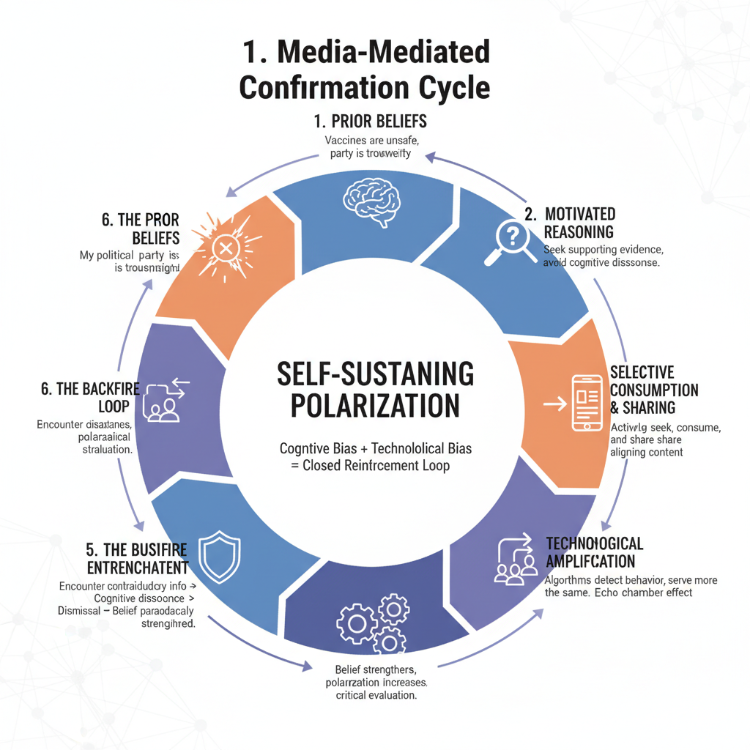
- The Backfire Loop: On the rare occasion the individual encounters contradictory information, the activated cognitive dissonance triggers a defensive motivated reasoning, leading to a "backfire effect". The contradictory evidence is dismissed as biased or flawed, and the original belief is, paradoxically, strengthened.

4. Moderating Factors and Interventions

4.1 Promoting Accuracy Goals (Media Literacy)
The "motivated reasoning" described by Kunda (1990) is directional (arriving at a desired conclusion). However, Kunda also identifies an alternative: accuracy-motivated reasoning. When people are motivated to be accurate, they "expend more cognitive effort... attend to relevant information more carefully, and process it more deeply, often using more complex rules". This accuracy motivation can lead to the reduction or elimination of cognitive biases.
This finding is the psychological foundation for media literacy interventions. Such programs aim to shift the user's goal from belief confirmation (directional) to truth evaluation (accuracy). By encouraging users to check sources, evaluate evidence, and consider alternatives, media literacy initiatives attempt to trigger the more complex, careful, and objective processing associated with accuracy goals.

4.2 Fostering Intellectual Humility
A second, potent moderator is the trait of intellectual humility (IH), defined as the recognition of one's intellectual limitations. The research by Knöchelmann and Cohrs (2024) provides critical evidence for its role in combating polarization.
Their study found that participants' self-reported intellectual humility was consistently negatively correlated with affective polarization. Furthermore, intellectual humility—in both the participant and the person they were engaging with—was found to be beneficial and sometimes "even necessary" to make participants approach (rather than avoid) a target person with contrary-minded views.
This directly counteracts the core mechanisms of the polarization cycle. Where confirmation bias leads to avoidance of dissenting views (the filter bubble), intellectual humility leads to approach and engagement. This willingness to engage leads to seeing political outgroups more positively and a higher willingness for intergroup contact, breaking the isolation of the echo chamber.

8. Conclusion
The polarization fragmenting modern society is not caused by media technology alone, nor is it a simple result of human psychology. It is the product of a vicious cycle where cognitive and technological biases reinforce one another.
As this paper has shown, the human tendency for confirmation bias and motivated reasoning is a given. In the past, this bias was constrained by a shared information environment. Today, media fragmentation , selective sharing , and algorithmic curation have created a near-frictionless system for belief reinforcement. This Media-Mediated Confirmation Cycle not only strengthens existing beliefs but also actively defends them through a backfire effect and a reduction in the critical evaluation of like-minded content.
The implications are profound. Interventions focused solely on "fact-checking" or "exposing" people to opposing views are likely to fail, as they trigger the defensive mechanisms of the cycle. Instead, effective interventions must target the cycle's root drivers. This includes media literacy programs designed to shift users from directional (confirmation) to accuracy-based reasoning , and broader societal efforts to foster intellectual humility, a trait that encourages the very engagement and openness that the current media ecosystem discourages.

References

- Barrera-Rodriguez, O., Pavlova, L., & Yang, L. (2025). Confirmation bias and asymmetric political polarization: Evidence from a media experiment in Germany. [Working Paper]. ZEW – Mannheim, Centre for European Economic Research.
- Johnson, B. K., Neo, R. L., Heijnen, M. E. M., Smits, L., & van Veen, C. (2020). Issues, involvement, and influence: Effects of selective exposure and sharing on polarization and participation. Computers in Human Behavior, 104, 106155. https://doi.org/10.1016/j.chb.2019.09.031
- Knöchelmann, L., & Cohrs, J. C. (2024). Effects of intellectual humility in the context of affective polarization: Approaching and avoiding others in controversial political discussions. Journal of Personality and Social Psychology: Interpersonal Relations and Group Processes. https://doi.org/10.1037/pspi0000462
- Kunda, Z. (1990). The case for motivated reasoning. Psychological Bulletin, 108(3), 480–498.
- Modgil, S., Singh, R. K., Gupta, S., & Dennehy, D. (2021). A confirmation bias view on social media induced polarisation during Covid-19. Information Systems Frontiers. https://doi.org/10.1007/s10796-021-10222-9.

